Basic Symbols |  | Pumps
 | Working Line-Pressure/Return | 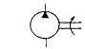 | Fixed Capacity with one Direction of Flow
 | Pilot Control Line- External/Internal Drain Line | 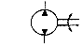 | Fixed Capacity with Two Directions of Flow  (MOTOR USE ON ORION ARM AND ISE WRIST)
 | Enclosure of two or more functions contained in one unit | 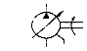 | Variable Capacity (with Undefined Control Mechanism One Direction of Flow
 | Flexible Connection | 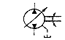 | Variable Capacity (with Undefined Control Mechanism Two Directions of Flow
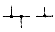 | Pipe Line Junction | 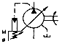 | Variable Capacity-Pressure Compensate Pump with One Direction of Flow
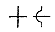 | Crossing -Not Connected | Motors
 | Hydraulic Source of Energy | 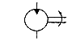 | Fixed Capacity Uni-Directional Output
 | Pneumatic Source of Energy | 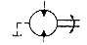 | Fixed Capacity Bi-Directional Output
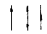 | Directions of Flow | 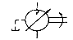 | Variable Capacity (with Undefined Control Mechanism Uni-Directional Output
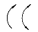 | Directions of Rotation | 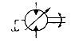 | Variable Capacity (with Undefined Control Mechanism Uni-Directional Output
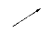 | Facility for Adjustment of: Spring Pump, Solenoid,Cylinder, Damping etc. | Cylinders
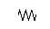 | Spring | 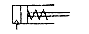 | Single Acting Spring Return (Pneumatic)  (USE INSIDE HARD-LINE CUTTER)
 | Restriction to flow Line | 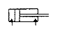 | Double Acting-Single Piston Rod (Hydraulic)  (USE ON ISE ARM)
 | Power Line Plugged | 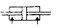 | Double Acting-Double Piston Rod
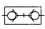 | Quick Release-Self Sealing Coupling-Connected (Mechanically opened) | 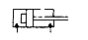 | Double Acting-Fixed Cushion at full area side only
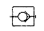 | Coupling-Blocked e.g. Gauge Point | 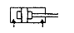 | Double Acting-Fixed Cushioning at both ends
 | Rotary Juction-One Connection | 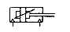 | Double Acting-Adjustable Cushioning at both ends (Pneumatic)
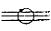 | Rotary Juction-Thre Connections | 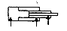 | Double Acting Telescopic Cylinder
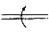 | Rotary Shaft-Uni-directional | 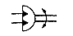 | Semi -Rotary Actuator Limited Angle
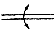 | Rotary Shaft-Bi-directional
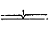 | Shaft-Detent Held
 | Pivoting Device

Control Valves |  | Controls
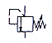 | Single Stage- Relief Valve (Adjustable) | 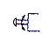 | By Twist
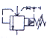 | Two Stage Relief Valve-Internal/External Pilot operated (Adjustable) | 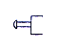 | By Push Button
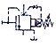 | Two Stage Sequence Valve-Internal/External Pilot operated ( Normally Closed Adjustable) | 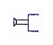 | By Pull Button
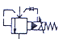 | Two Stage Proportional Pilot Operated Relief Valve | 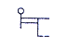 | By Lever
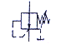 | Single Stage Reducing Valve (Adjustable) | 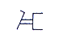 | By Foot Pedal
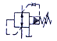 | Two Stage Reducing/Relieving Valve-Internally Pilot Operated (Adjustable) | 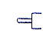 | By Plunger
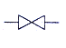 | Gate Valve | 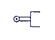 | By Roller
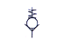 | Check Valve-Spring Closed | 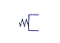 | By Spring
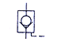 | Pilot to Open Check Valve | 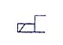 | By Single Solenoid (One winding)
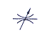 | Adjustable Restrictor Valve | 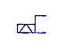 | By Single Solenoid (Two Opposed Windings)
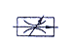 | Variable Pressure Compensated Flow Control Valve | 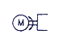 | By Electric Motor  (ELECTRIC MOTOR USE ON VEHICLE)
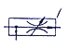 | Priority Flow control | 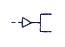 | By Pneumatic Pilot Pressure (Direct)
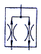 | Flow Divider/Combiner Fixed Ratio Outputs | 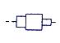 | By Differential Pilot Areas
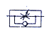 | One Way Adjustable Restrictor Valve-With Free Flow in One Direction & Restricted Flow in the other Direction | 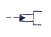 | By Oil Pressure (via Control)
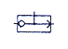 | Shuttle Valve | 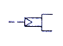 | By Pneumatic Pressure (via control)
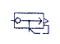 | Quick Exhaust Valve (Pneumatic) | 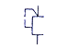 | By Internal Control Path
 |  | 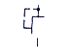 | By External Control Path
 |  | 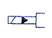 | By Solenoid Operated Pilot Valve
 |  |  | Notes: Valve control symbols may be drawn at any convenient position across end of valve rectangle

Directional Control Valves |  | Miscellaneous
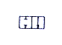 | Two Position Valve-Two Port Flow Paths Blocked/Through | 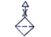 | Air Breather
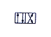 | Two Position Valve-Four Port Flow Paths Through/Crossed  SOLENOID VALVE INSIDE RATE PACK | 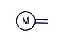 | Electric Motor
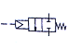 | Two Position-Two Part Spring Return Pilot Operated Valve (Pneumatic) | 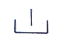 | Reservoir-Return Above Oil Level
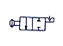 | Two Position Two Part Push/Pull Detent Held Valve | 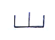 | Reservoir-Return Below Oil Level
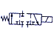 | Two Position Three Part Single Solenoid Operated Spring Return Directional Valve (Transient Port Connection Shown) | 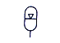 | Accumulator-Fluid Maintained Under Pressure by Intert Gas
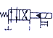 | Two Position Four Port Solenoid Pilot Operated Directional Valve with Spring Return (External Solenoid Pilot & Drain Connection-Solenoid with Mechnaical Override) | 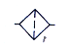 | Filter
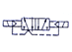 | Two Stage Five Port-Solenoid Pilot Operated Pneumatic Directional Valve | 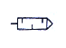 | Pneumatic Silencer
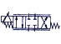 | Electro Hydraulic Servo Valve Spring Centred with Variable Flow Area-Four Port Type Single Actuator-Two Windings | 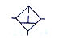 | Filter with Water Trap (Manual Drain)
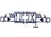 | Proportional Solenoid Pilot Operated Directional Valve with Variable Flow Area Four Port-Two Actuators | 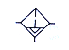 | Filter with Water Trap (Automatic Drain)
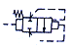 | Logic Valve-Pilot Operated. Spring Biased with Differential Pilot Areas (Normally Closed-Spool Type) | 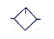 | Lubricator
 | Logic Valve-Pilot Operated. Spring Blased with Differential Pilot Areas (Normally Open-Seated Spool) | 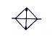 | Cooler (No Indication of Cooling Method)
 |  | 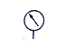 | Pressure Gauge
 |  | 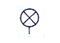 | Pressure Indicator
 |  | 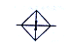 | Heater
 |  | 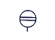 | Level Gauge
 |  | 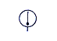 | Thermometer
 |  | 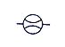 | Flow Meter
 |  | 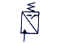 | Pressure Switch (Hydraulic)
 |  |  | Thermostat
 |  | 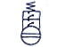 | Oil Level Switch (Two Level Switching)
 |  | 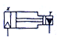 | Intensifier- Air/Oil

